Q1.

Output is 1.

Q2.

Output is 1 1.

Q3.

Output is 2.

Q4.

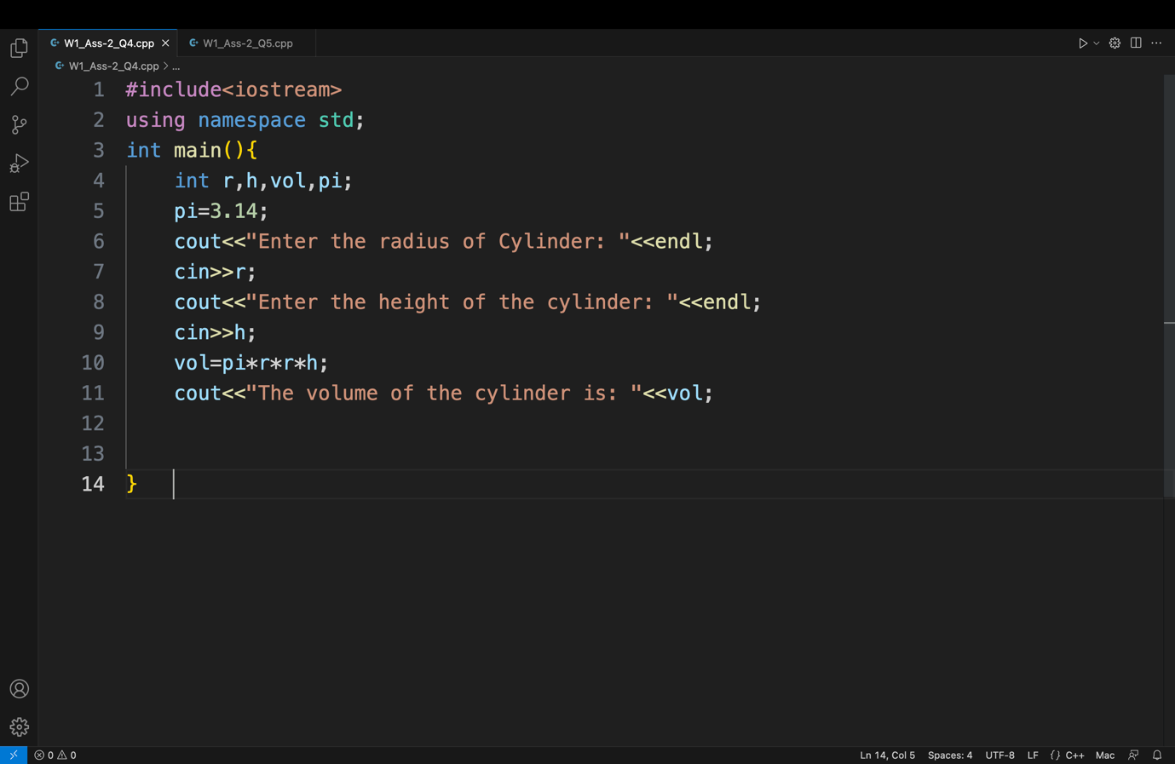

Q5.

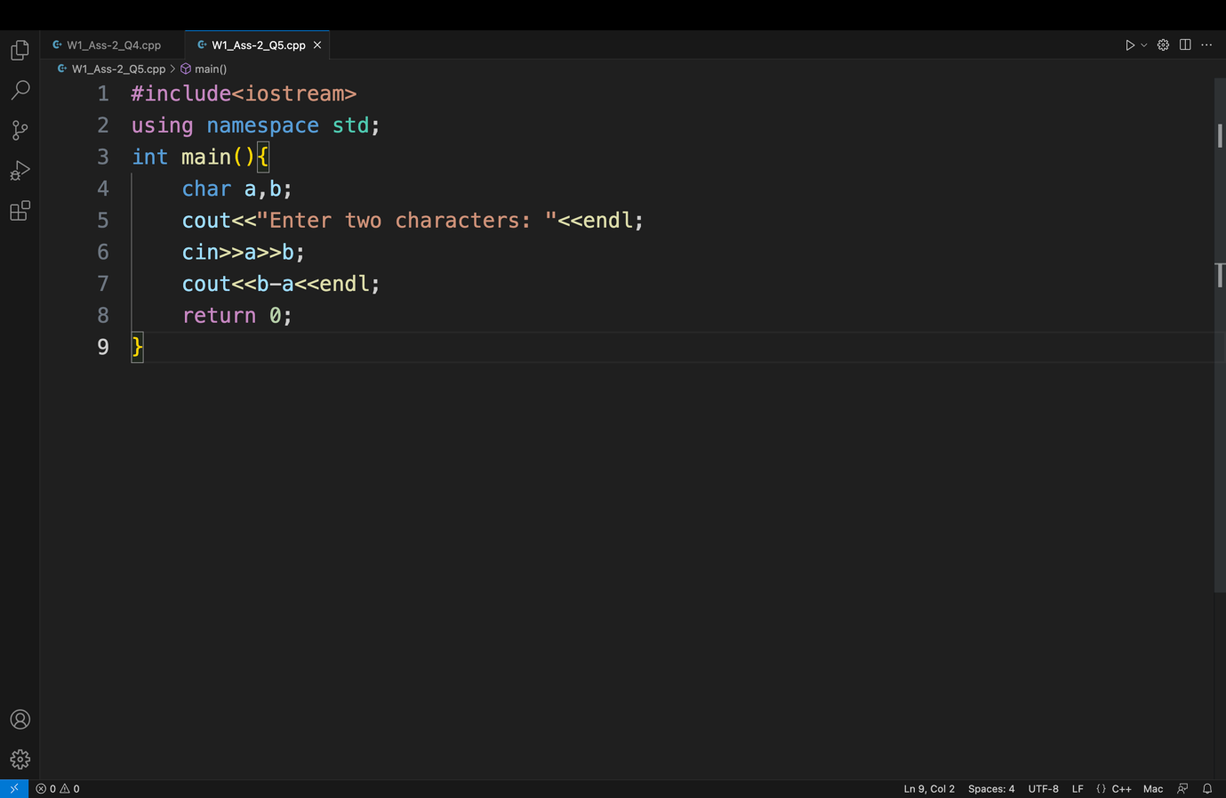

Q6.

Output is 49.